Implementation of Hashing in Virtual Tour

Kuhu Gupta¹, Aishwarya Shastry¹, Devesh Krishnani¹, Mridu Sahu¹
Govind P. Gupta¹
¹ Department of Information Technology, National Institute of Technology Raipur, India
{kuhu.gupta08, aishwarya.shastry231, dev.krish23}@gmail.com
{mrisahu.it, gpgupta.it}@nitrr.ac.in

Abstract. . Virtual environments are being used in a wide range of academic and commercial applications. It can give users a natural feeling of the environment by creating realistic virtual worlds. Virtual tours are used to familiarize a user with his surroundings. But most of them are just images rotating and do not provide end user the functionality of navigating around the tour. This leads to the user terminating the virtual tour. Many virtual tours are large in size because of repetition of images in several places, this leads the virtual tour to lag, thus, aﬀecting end user experience. In this work, virtual tour application is made using graphics rendering by Three.js, hashing and cube mapping. The application allows to take a virtual tour of NIT Raipur. The article finds a relationship between the graphics rendering of the scene and creation of navigation paths to ease virtual touring.

Keywords: Virtual tour, Three.js (JavaScript Library), Skybox, Hashing, Navigation

1 Introduction

Nowadays, many virtual tours are available on the Web and this gives us an evidence that virtual tours are becoming accessible to a larger and more diverse audience [1]. The important aspect is that students from all over the country are interested to take admission in colleges. Therefore, there is a lot of interest in the public for visiting educational institutes. For those who want to experience the aura of the college sitting at home, virtual tour is an asset. This virtual tour application would also be helpful for the college website as it can be taken online by anyone in any part of the world who wants to know about the campus and wants to explore all the facilities that exist in the campus. The web application navigates through all the amenities that are present in the campus. It takes the viewer on a tour of each department starting from the entrance of the institute. The signiﬁcance of the virtual tour is that we get a panoramic view of the campus which will enhance our journey on the Internet. The users can navigate and interact with the system, yet they are not allowed to walk through the walls. Diﬀerent camera views are set at diﬀerent locations and at diﬀerent angles to provide natural views of a scene.
The paper describes an approach that allows a layman to take a virtual tour of a building. In addition, the tour is the combination of images rendered on the sides of a 3D cube and navigation paths which can easily adapt to the needs of a user [2].Three.js and cube mapping generates 3D cube map by ﬁrst rendering the scene six times from a viewpoint, with the views deﬁned by an 90 degree view frustum representing each cube face [3] .The optimization of the entire virtual tour is achieved by the concept of hashing. A lookup table is created to store images in a local database and a hash function to append some random digits to increase the security. The paper illustrates the results by means of a real case, which is a reconstruction of National Institute of Technology, Raipur. In the next section an overview of the related work is presented. Then, some of the components of the system are discussed more in detail: Three.js (Section 3)Skybox and Cube mapping (Section 4), Thumbnail navigation using OrbitControls.js (Section 5) and Hashing (Section 6)Selective Navigation(Section 7),Methodology(Section 8),Future developments(Section9). The last two sections contain some result analysis for research and the conclusions.

2 Related Work

In recent years many virtual campuses have been built [4]. A virtual model for Avcilar campus of Istanbul University has been built [5]. A virtual tour model of IIT Gandhinagar has been built which consists of a panoramic image rotating at a 360 degrees where clickable images take us to another panorama [6]. Similarly, IIT Kanpur and IIM Bangalore Virtual tour consists of a menu of the landmarks present in the campus giving a spherical view of each landmark [7].Amherst college and Harvard college virtual tours provides a tourist guide who describes the sliding images which show us the important landmarks of the college [8]. The virtual tour of Harvard college has a menu which contains 360 degrees panoramas, videos and photos [9].The University of Cambridge provides virtual tour of its every college by stitching together panoramas to form a cube enabling real time viewing[10].The renowned Oxford University gives the satellite view of its landmarks in its virtual tour by stitching panoramic images to form a moving cube [11].Nanyang Technological University also has its own virtual tour[12].In the present scenario, virtual reality and web technologies in the field of distance education for web-based medical simulations play a significant role [13].

3 Three.js(JavaScript Library)

WebGL (Web Graphics Library) is a JavaScript API used to render 2D and 3D graphics to the screen in a compatible browser [14]. Programming directly in the WebGL API can be very complicated at times but there are libraries that simplify this and one such library is Three.js [15].Three.js is a lightweight JavaScript library which is used to create 3D computer graphics on a web browser [16].It is a cross browser JavaScript API Cross Browser is the ability of a web application to work well in browsers that it is compatible with and to stop in a digniﬁed way when its features do not match the browser [17].Three.js supports renderers, scenes, lights, loaders, cameras and animation [18]. The sequence of steps which occur while rendering the skybox to make a virtual tour using the diﬀerent features of Three.js is shown in Figure 1[19]. First of all, a scene is setup with a camera and renderer [20]. The Renderer generates the ﬁnal detailed images, based on current camera, 3D geometries, materials and lighting setup [21].The Camera determines what is actually rendered on the screen while lights have an eﬀect on how the materials are shown and used when creating shadow eﬀects [22].Every object that is rendered in Three.js is a Mesh consisting of geometry and material [23].A geometry holds all data necessary to describe a 3D model consisting of vertices and faces [24]. Materials describe the appearance of objects by supporting textures for adding detail to a 3D object by applying an image to one or more of the faces of that object [25].
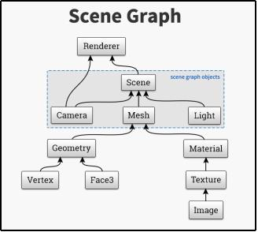
Fig 1. Rendering of a scene

4 Skybox and Cube Mapping

Skybox is a procedure for creating backgrounds in computer and video games, The Sky, distant mountains, buildings and other objects are put across at the cubes faces using cube mapping technique [26].The cube map is created by ﬁrst rendering the scene six times from a viewpoint, with the views deﬁned by a 90 degree view camera placed inside the cube [27].The movement of the cube along with the camera creates a vision of three-dimensional surroundings [28].The concept of cube mapping is clearly represented in Figure 2 [29].

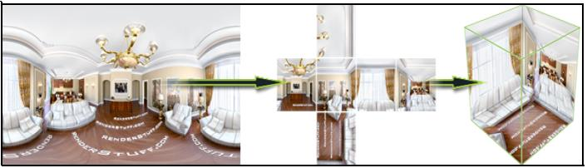
Fig 2. Cube Mapping

5 Thumbnail Navigation using OrbitControl.js

To view all sides of the skybox it becomes crucial to add Orbit controls mode [30].While using this mode pressing left click or right click in mouse rotates the camera around the center of the scene [31].It allow us to drag the mouse across the mesh and orbit around it. It also allows the mouse wheel to be used to zoom in and out of the mesh [32].To make it easier for the user to navigate inside the skybox, orbit control is added to the virtual tour as shown in Figure 3.

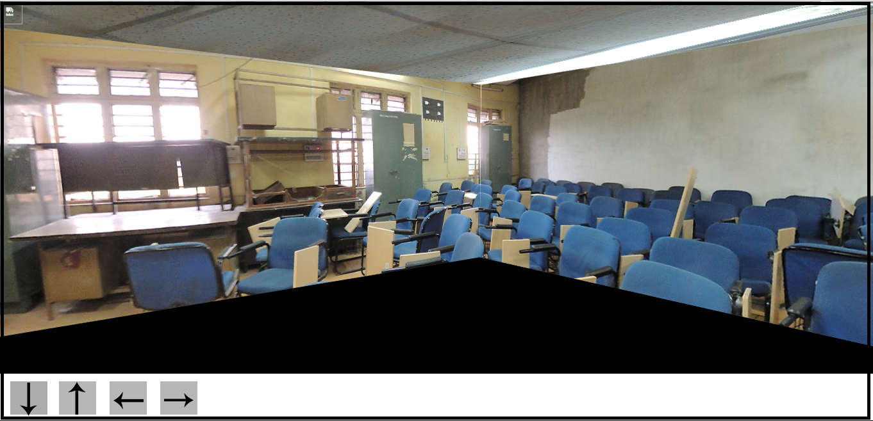
Fig 3. Arrow keys are used to navigate inside the skybox

6 Hashing

Hashing is used to index and retrieve items in a database [32]. Using hashed value the items can be retrieved faster [33].Here a n*n matrix is created, the first column contains the hashed value of initial skybox of every place and their corresponding columns contains the hashed value of the places that can be visited through them [34]. MD5 hashing functions is used to reduce the size of array, it provides cryptic address which leads to more security [35].The flow of movement in the campus in an optimal way is shown in Figure 4.

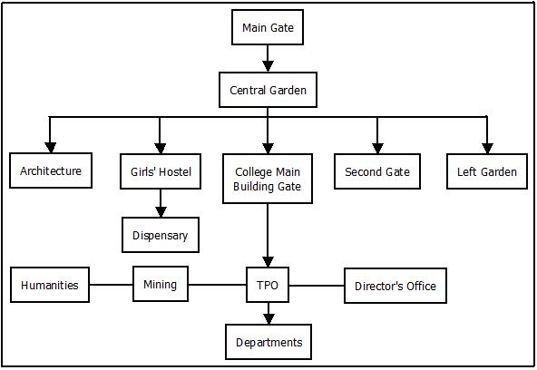
Fig 4. Flow Diagram of Navigation

7 Selective Navigation

JQuery is a cross-platform JavaScript library designed facilitate to the client-side scripting of HTML [36]. Tipue Search is a search engine jQuery plugin, It's free, open source, responsive and fast.[37] The live mode of Tipue Search indexes the list of pages, but no other content and the entry in the search box lists out all the related pages on the site to ease selective navigation [38].

8 Methodology

The article used methodology for virtual touring application and the flow diagram for this is shown in Figure 5 and step by step walkthrough is mentioned in Table 1. The figure clearly shows the exact features available in our virtual tour. It consists of two parts, Graphics Rendering and Navigation. Hashing is used to connect both. Navigation available is of two types, Selective Navigation and Thumbnail Navigation.
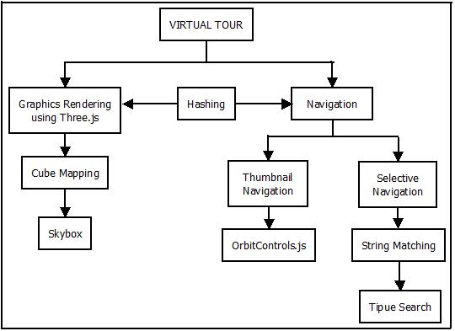
Fig 5. Virtual Touring Application Flow Diagram

Table 1. Font sizes of headings. Table captions should always be positioned above the tables.

Steps | Description
Step 1 | Use graphics rendering available in three.js.
Step 2 | Cube mapping is used for formation of a cube where the camera is put
Step 3 | Camera is kept at inside of the cube thus making it a skybox
Step 4 | Navigation is used to help user navigate through the campus
Step 5 | Selective Navigation is used for Navigating through landmarks and department
Step 6 | Orbit controls.js control the arrow keys which are used to navigate inside the skybox
Step 7 | Thumbnail Navigation is used to see the sides of the cube
Step 8 | The String entered in search box is first matched with the database
Step 9 | Tipue search helps in taking the user to the specific location

The outcomes of methodology are discussed in the result section.

9 Future Developments

Future work consists of using a real person for the virtual guide. This virtual guide rotates 360 degrees instead of the camera. The user can see through the eyes of the Virtual guide. The goal is to include text to speech and speech to text for easy navigation for physically disabled. The application can be extended to aim to include live event viewing. Application can include videos instead of images and let the user experience a real time experience. Application can be modified to use digital image processing for modeling the surrounding and thus create a virtual tour with more effective real life effect, the object in the tour would have freedom to go anywhere in the tour without changing the instance of application.

10 Result Analysis

Virtual Tour provides a simulation of a surrounding thus allowing them to view it while not being physically present. It allows the user to observe and experience the place. Virtual tour is built using three.js which is a library used for many other computer graphics application over the world. It is simple and efficient to use. The virtual tour uses images of environment it is based on thus providing a unique experience. The users are allowed to freely navigate the virtual tour using an object but cannot go through walls. Virtual tour also has a search facility for selective navigation plus speech to text and text to speech navigation for physically disabled.

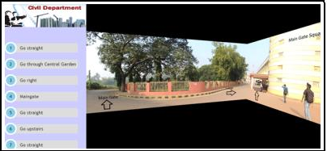
Fig 6. The left side of the image shows the navigation options

The virtual tour has its limitations. It requires high speed internet to function properly. The browser should support JavaScript and WebGL. Images of high quality and low size are required to make the tour efficient. Since three.js is a constantly evolving online library therefore proper maintenance is required. Figure 6 and Figure 7 are the screenshots of the virtual tour of a department navigating the user from the entrance to the department.

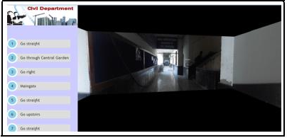
Fig 7.The right side of the image shows the skybox of the entrance of civil department

11 Conclusion

Proposed article shows, a successfully created virtual tour implemented along with hashing. NIT Raipur is used as a data set for the project. Every Landmark and Department is covered. If a user wants to know about NIT Raipur. He/she can tour the campus using our Virtual Tour. The Technique “Skybox” made using Three.js was the core part of our project. Hashing algorithm was used for selective navigation. Our analysis gave a space complexity of O (n*n) and time complexity of O (n). Using a cube proved to be more efficient and beneficial both in term of space and time as time taken to render square images is quite less when compared to rendering a sphere as only two panorama images are required to create the Cube, whereas more than ten images were required for a sphere.

12 References

- Frederic Kleinermann, Olga De Troyer, Christophe Creelle, Bram Pellens: Adding Semantic Notaions,Navigation Paths and Tour Guides to Existing Virtual Environments 13th International Conference VSMM(2007)
- Marc Pollefeys , Luc Van Gool ,Ive Akkermans ,Dirk De Becker, KrisDemuyn ck: A Guided Tour to Virtual Sagalassos. Proceedings of the conference on Virtual reality, archeology, and cultural heritage (2001)
- Fernando, R., Kilgard, M.: The Cg tutorial. Addison-Wesley, Boston, Mass. (2003).
- Khan, F. et al.: Using VRML to Build a Virtual Reality Campus Environment. World Congress on Engineering. (2008).
- M.Nusret SARISAKAL, K. Gökhan CEYLAN: “A Virtual Reality For Avcilar Campus Of Istanbul University Using VRML,” Istanbul University- Journal of Electrical and Electronics Engineering, Vol 3, no 2 ( 2003).
- 4dea.com,: 4Dea| Experience beyond 3D Tours| 360 Interactive Virtual Tours, http://www.4dea.com/index.html#.
- Fotobubbles.com,: IIT Kanpur Virtual Tour - see India's premier institute!, http://www.fotobubbles.com/portfolio/iit-kanpur-virtual-tour/.
- Amherst.edu,: Virtual Tour | Amherst College, https://www.amherst.edu/aboutamherst/visiting/virtualtour.
- College.harvard.edu,: Virtual Tour | Harvard College, https://college.harvard.edu/admissions/visit/virtual-tour.
- Kings.cam.ac.uk,: Virtual tour of the college, http://www.kings.cam.ac.uk/visit/virtual-tour/.
- Chem.ox.ac.uk,: Virtual Tour of Oxford, http://www.chem.ox.ac.uk/oxfordtour/.
- Sourin, A.: Nanyang Technological University virtual campus [virtual reality project]. IEEE Comput. Grap. Appl. 24, 6, 6-8 (2004).
- Dimitropoulos, K. et al.: Building Virtual Reality Environment for Distance Education on the Web: A case study in Medical Evaluation. INTERNATIONAL JOURNAL OF SOCIAL SCIENCES. 2, 1, (2008).
- Tavares, G.: WebGL Fundamentals. (2012).
- Steir, G.: Getting started with WebGL and Three.js, http://solutiondesign.com/blog/-/blogs/getting-started-with-webgl-and-three-1, (2012).
- GitHub,: mrdoob (Mr.doob), http://github.com/mrdoob.
- Jibbering.com,: Browser Detection (and What to Do Instead), http://jibbering.com/faq/notes/detect-browser.
- GitHub,: mrdoob/three.js, https://github.com/mrdoob/three.js/wiki/Features.
- Davidscottlyons.com,: Intro to WebGL with Three.js, http://davidscottlyons.com/threejs/presentations/frontporch14/#slide-16.
- Packtpub.com,: Working with the Basic Components That Make Up a | PACKT Books, https://www.packtpub.com/books/content/working-basic-components-make-threejs-scene.
- Clara.io,: Renderering Basic · Learn · Clara.io, https://clara.io/learn/user-guide/rendering/rendering_basics.
- Packtpub.com,: Working with the Basic Components That Make Up a | PACKT Books, https://www.packtpub.com/books/content/working-basic-components-make-threejs-scene.
- Steir, G.: WebGL and Three.js: Lighting, http://solutiondesign.com/blog/-/blogs/webgl-and-three-js-lighting/, (2014).
- Geometry of 3-D model, http://threejs.org/docs/Reference/Core/Geometry.
- WebGL, L. et al.: Three.js - Materials and Texture | PACKT Books, https://www.packtpub.com/books/content/threejs-materials-and-texture.
- Greene, N.: Environment Mapping and Other Applications of World Projections. IEEE Comput. Grap. Appl. 6, 11, 21-29 (1986).
- Fernando, R., Kilgard, M.: The CG Tutorial-The Definitive Guide to Programmable Real-Time Graphics. Addison-Wesley Longman Publishing Co, Boston (2003).
- Etienne, A., Etienne,J.: Lets Do a Sky, http://learningthreejs.com/blog/2011/08/15/lets-do-a-sky/, (2011).
- Renderstuff.com,: 360 panorama in 3ds Max tutorial, http://renderstuff.com/creating-virtual-360-panorama-cg-tutorial/.
- Dirksen, J.: Three.js essentials. Packt Pub., Birmingham, UK (2014).
- Dun, R., Fan, Z., Yao, H., Zhang, S.: A Three-dimensional Scene Simulation System for Evaluating Textures of Fabrics. International Conference on Logistics Engineering, Management and Computer Science (LEMCS 2015). pp. 138-143. Atlantis Press (2015).
- Pettit, N.: The Beginner’s Guide to three.js, http://blog.teamtreehouse.com/the-beginners-guide-to-three-js, (2015).
- H. Cormen, T., E. Leiserson, C., L. Rivest, R., Stein, C.: Introduction to Algorithms. The MIT Press, Massachusetts Institute of Technology,Cambridge (2009).
- Konheim, A.: Hashing in computer science. Wiley, Hoboken, N.J. (2010).
- Peter Kankowski.: "Hash functions: An empirical comparison”
- Schneier, B.: Cryptanalysis of MD5 and SHA: Time for a New Standard, https://www.schneier.com/essays/archives/2004/08/cryptanalysis_of_md5.html, (2004)
- jquery.org, j.: jQuery, https://jquery.com/.
- Tipue.com,: Tipue, http://www.tipue.com/?d=1.
- jquery.org, j.: tipue | Search Results | jQuery Plugin Registry, https://plugins.jquery.com/?s=tipue

